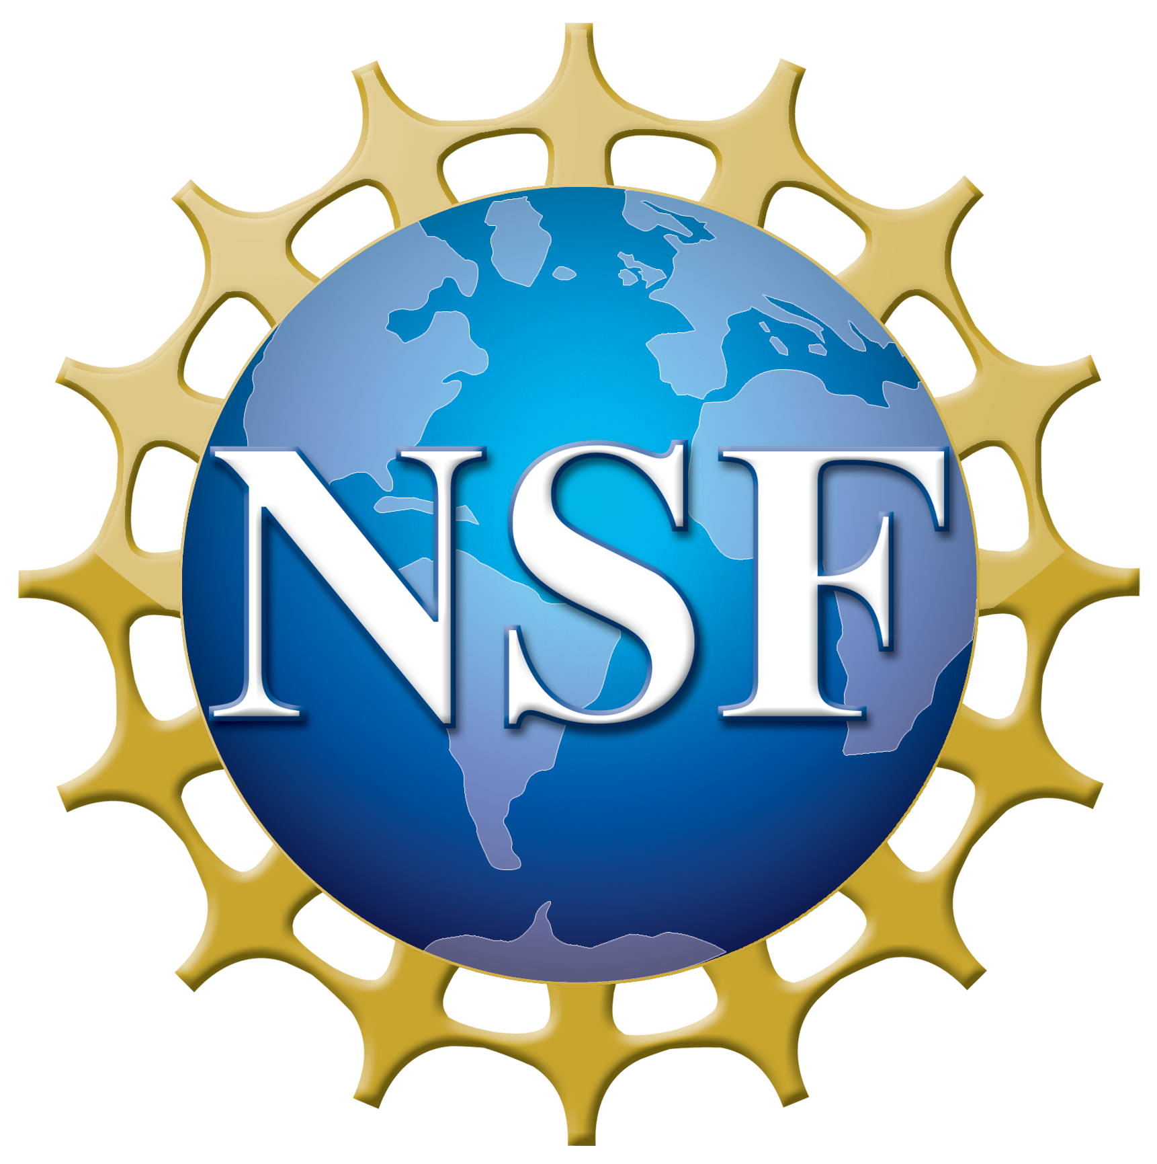
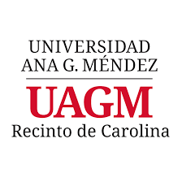
National Science Foundation Scholarships in Science, Technology, Engineering, and Mathematics Program (NSF S-STEM)
Grant Award No. 1930406

Division of Science and Technology

Application Check List:
Proof of admission to one of the BS programs of the Division of Science and Technology, UAGM-Carolina campus
Scholarship Application Form
Personal Statement
CV or resume
Recommendation letter waiver - signed and forwarded to the STEM professor that will provide recommendation.
Recommendation letter form - one (1) from your STEM professor.
A recent transcript (as of December 2020 grades)

Application Deadline: January 11, 2021
Note: The applications will be accepted on a rolling basis; we will close the application process when we have filled all positions. To maximize your chance to be considered, please submit your materials before the application deadline.
Scholarship application package with all required documents must be delivered by email to:
Dr. Mariel E. Pérez Vélez
NSF S-STEM Principal Investigator and Director,
Division of Science and Technology
nsfsstem-ca@uagm.edu / copy to mperez244@uagm.edu

Mrs. Myrna Flores
Assistant Director Office of Scholarship and Internship
miflores@uagm.edu

Documents should be sent in PDF format. The email title should read: "NSF S-STEM application documents – student full name."
National Science Foundation Scholarships in Science, Technology, Engineering, and Mathematics Program (NSF S-STEM)
Grant Award No. 1930406

Division of Science and Technology

Scholarship Application Form

- General Information:

Applicant name

Gender M F Age Date of birth (mm/yyyy)

US Citizenship Yes No Permanent Resident Yes No

Residential Address:

Mailing Address (if different from residential):

Phone No.: (day) (evening)

Cell Phone No.:

Personal E-mail:

UAGM Student ID No. (if available): S0
Institutional E-mail (if available): @email.uagm.edu

Year of study: First year (freshmen) Second year (sophomore)
Third year (junior) Forth year or higher (senior)
GPA:

How did you hear about the NSF S-STEM Scholarship Program?

- Family information:

Father’s name Cell phone no.

Mother’s name Cell phone no.

- Applicant educational and professional interests’ profile:

Which BS program in UAGM - Carolina campus are you enrolled?

Microbiology
Biotechnology
Biology

Please, indicate your level of interest in pursuing the following degrees:

Not interested Somewhat interested Very interested

B.S. Degree 1 2 3
M.S. Degree 1 2 3
M.D. Degree 1 2 3
Ph.D. Degree 1 2 3
D.V.M. Degree 1 2 3
M.D./Ph.D Degree 1 2 3
D.V.M./Ph.D. Degree 1 2 3

Other (specify)

Have you been involved in a science project or participated in a scientific research experience?
Yes No

If yes, list and briefly describe the science project or your scientific research experience.

List extracurricular activities in which you have participated in college or in the community such as: sports, arts, volunteer service, hobbies, etc. Indicate the date when you participated, the name of the organization or entity and your participation in it.
(Activity / time of participation / name organization / role or participation)

What are your expectations while participating in this scholarship program?
(Rank as 1 – most important, 5 – least important)
Cover my tuition and other expenses
Research Opportunities
STEM-related Field Trips
Seminars & Workshops
Summer internships

Personal Statement:
Please attach a personal statement (Arial 11, minimum of 800 words) describing your background, what brought you to UAGM-Carolina campus, your interests in pursuing a career in biological sciences, what prompted your interest in your major, your career plans and how the scholarship will benefit your studies. You can add any other experiences you think are relevant to your qualifications for this scholarship.
- Certifications and signature

I have read and understand the criteria for the scholarship for which I am applying. I understand that applying does not guarantee an award. I attest that all information provided is complete and accurate to the best of my knowledge. I hereby give UAGM - Carolina campus permission to share this information in compliance with the Family Education Rights and Privacy Act (FERPA) for the purpose of recruitment, employment, and other scholarship opportunities only.

Student's name Student's signature ___________________
Date

Complete application form must be returned with the requested documents NO LATER THAN January 11, 2021 to:

Dr. Mariel E. Pérez Vélez
NSF S-STEM Principal Investigator and Director,
Division of Science and Technology
nsfsstem-ca@uagm.edu / copy to mperez244@uagm.edu

Mrs. Myrna Flores
Director Comprehensive Student Development Office
miflores@uagm.edu

Documents should be sent in PDF format. In the email subject, please write “NSF-S-STEM application documents – your complete name”

